**1A2B (Bulls & Cows) Game Design/Development**

We are about to develop the game, called 1A2B (aka. Bulls & Cows) in Python. The game is played as follows:

1. In the beginning, the game will randomly pick four different digits as the target number (e.g., 2468) to be guessed by the player.
2. In each round of the game, the player can guess four digits, e.g., 1234. If an user-guessed digit hits the target number and its position is the same as that in the target number, it is considered as 1A (or 1 bull). If an user-guessed digit hits the target number but its position is different from that in the target number, it is considered as 1B (or 1 cow).

For example, if the target number is 2468 and the user guessing is 1234, the result of this round is 2B because both digits 2 and 4 hit the target but their positions are wrong. If the user guessing is 2478, the result of this round is 3A because both digits 2, 4, and 8 hit the target number, and their positions are all correct.

1. The player wins the game if his/her guessing results in 4A (or 4 bulls), i.e., all the digits appear in the target number, and their positions are correct.

The screen shot of the game could be as follows:

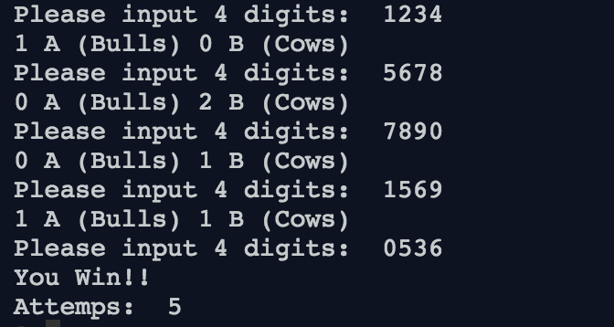

More information about the game: https://en.wikipedia.org/wiki/Bulls_and_Cows

**Discussion 1**

To play the 1A2B game, what are the steps (procedures) needed? What is the flow of them? Come up with your design (algorithm) by pseudocode/flowchart first.

**Discussion 2**

Based on your design, define the prototype of functions corresponding to each step.

* What is the functionality?
* How many parameters? What are they?
* The return object of the function

**Discussion 3**

Implement each function according to your design.

**Discussion 4**

Combine all functions you developed to complete the game.

Guide for Instructor

**Discussion 1**

* The purpose of this question is to let the students practice applying abstraction on algorithms. The students need to think about what are the required steps to play the game.
* Example pseudocode:
  1. Generate the target (4 digits) for user guessing.
  2. Get the number guessing from users
  3. Compare the user guessing with the target
  4. If the user guessing is not correct, go to step 2.
  5. If the user guessing hits, terminate the game.

**Discussion 2**

* Let the students define the interface/prototype of each step in Python first. Remind the students not to worry about the implementation in this stage.
* Example code, 1A2B.py, is provided for reference.

**Discussion 3**

* The purpose of this question is to let the students define Python functions.
* To randomly generate the target 4 digits for guessing, it is useful to import random module and use the shuffle() method.
* To obtain valid inputs from users, the string method isdigit()is useful.
* To compare user guessing with the target, nested loops may be required.
* Example code, 1A2B.py, is provided for reference.

**Discussion 4**

* The purpose of this question is to let the students utilize the functions they developed to complete the game development.
* From the main program, remind the students how the functions abstract their algorithm.
* Example code, 1A2B.py, is provided for reference.